**World Hepatitis Day Interactive Map**

Request is to create an interactive map (in Flash) to insert into a News Channel article on client’s intranet. Something similar was done last year by previous agency, and they really like this look (screen shots are below).

The image should be a world map, with the following countries or regions marked with a “pin” (or similar image) at the appropriate spot on the map and the country or region name:

1. Argentina
2. Australia
3. Brazil
4. Bulgaria
5. Canada
6. Colombia
7. Croatia
8. Hong Kong
9. India
10. Latin America Region
11. Malaysia
12. Mexico
13. Philippines
14. Serbia
15. Singapore
16. Slovenia
17. Thailand
18. UK
19. US
20. Venezuela
21. Vietnam

When the reader clicks on the country name/pin, a pop-up would come up with a paragraph of information (2-3 sentences – we have approved content and can provide immediately) about activities/programs in that country for World Hepatitis Day. In some instances, the pop-up will include a hyperlink to another page or article. The client has also provided a few images that they would like to include within the pop-up if at all possible.

Sample article page:

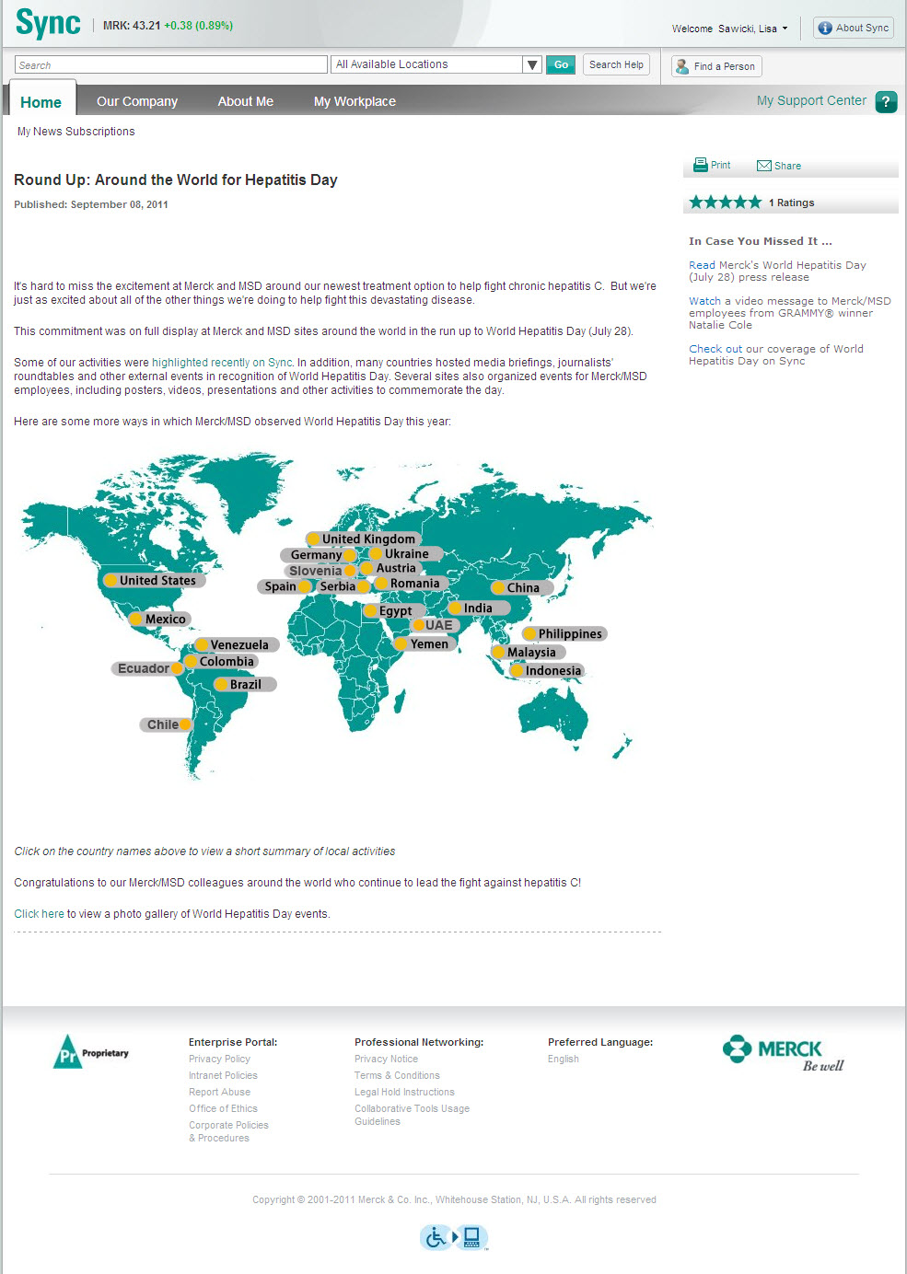

Details – when you click on each country name, you get a pop-up:

